**DAILY ONLINE ACTIVITIES SUMMARY**

|  |  |  |  |  |  |  |  |  |
| --- | --- | --- | --- | --- | --- | --- | --- | --- |
| **Date:** | 23-05-2020 | | | | | **Name:** | K S Prajwal | |
| **Sem & Sec** | Vi A sec | | | | | **USN:** | 4AL18CS032 | |
| **Online Test Summary** | | | | | | | | |
| **Subject** | | DATA COMUNICATION | | | | | | |
| **Max. Marks** | | 30 | | **Score** | | | 25 | |
| **Certification Course Summary** | | | | | | | | |
| **Course** | Computer Vision Essentials | | | | | | | |
| **Certificate Provider** | | | Greatlearning.in | | **Duration** | | | **1.5 hr** |
| **Coding Challenges** | | | | | | | | |
| **Problem Statement:** 1. Triangular numbers  2. Find the product | | | | | | | | |
| **Status:** completed | | | | | | | | |
| **Uploaded the report in Github** | | | | | yes | | | |
| **If yes Repository name** | | | | | <https://github.com/alvas-education-foundation/KS_Prajwal> | | | |
| **Uploaded the report in slack** | | | | | yes | | | |

Online Test Details: (Attach the snapshot and briefly write the report for the same)

Certification Course Details: (Attach the snapshot and briefly write the report for the same)

Coding Challenges Details: (Attach the snapshot and briefly write the report for the same)

ONLINE TEST:

The online test was from module 1 and module 2 which was about the introduction to data communication, about network models, digital transmission, analog transmission and introduction to physical layer. There were 30 questions and the duration were 40 minutes. The questions were optimal and were easy. The score that I got in the test is 25/30.

**Snapshot**:

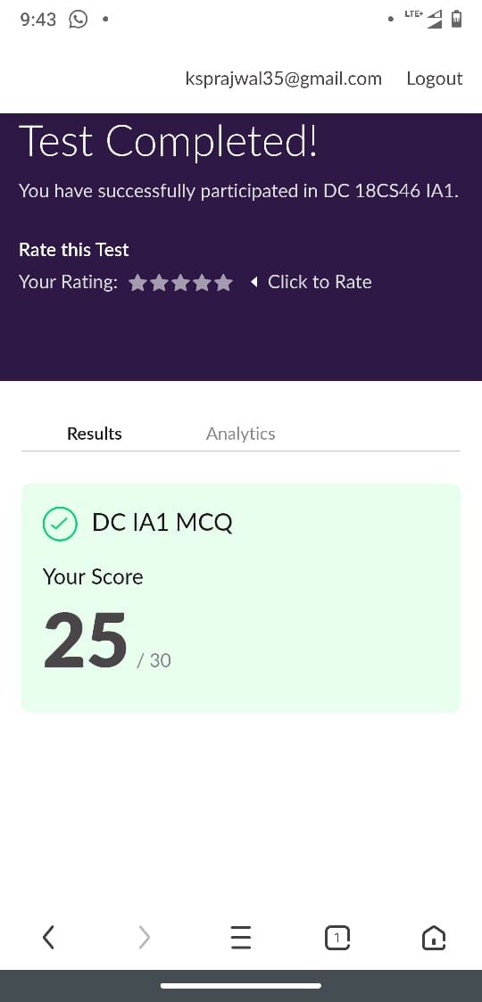

Snapshot of certification course:

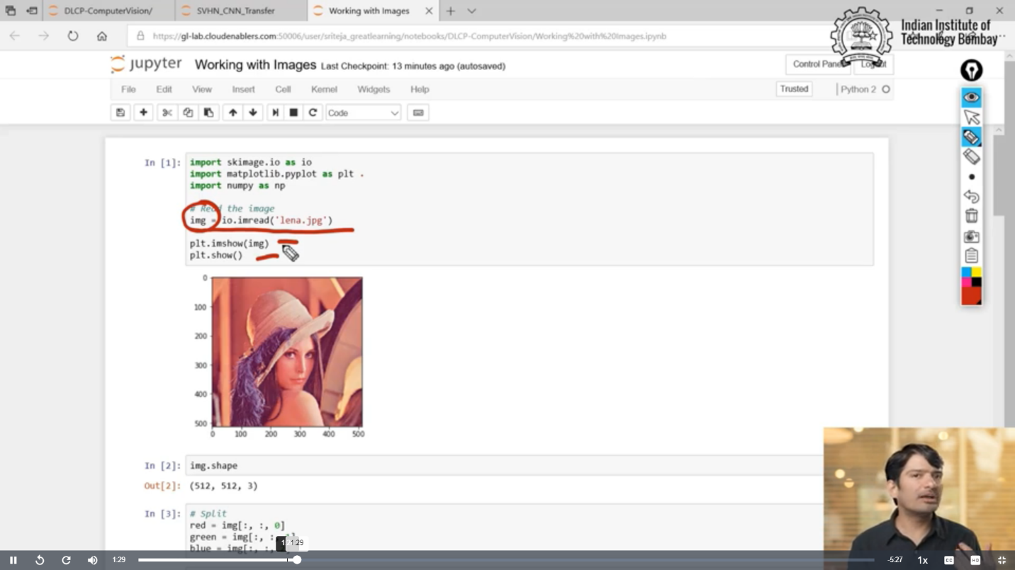

It was about the property of the image, changing the property and removing disturbance etc

**Online coding:**

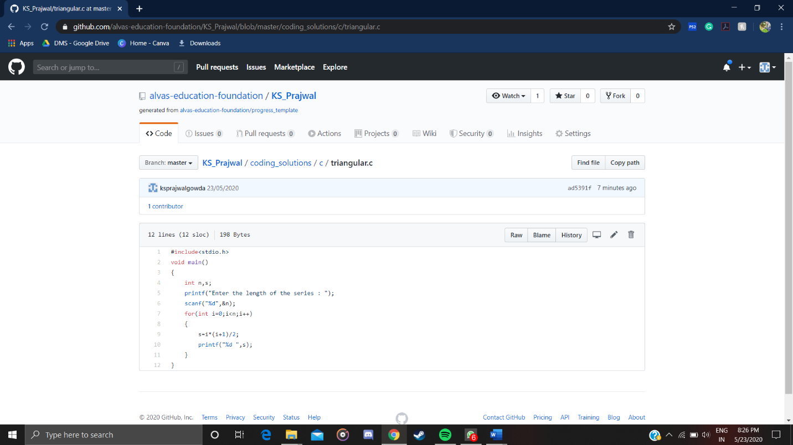Problem 1: (using C language) Write a program to print n triangular numbers.

Problem 2: (Using Python) You have been given an array A of size N consisting of positive integers. You need to find and print the product of all the number in this array modulo (10^9)+7

